Game project Idea:

(screenshots stolen from youtube)

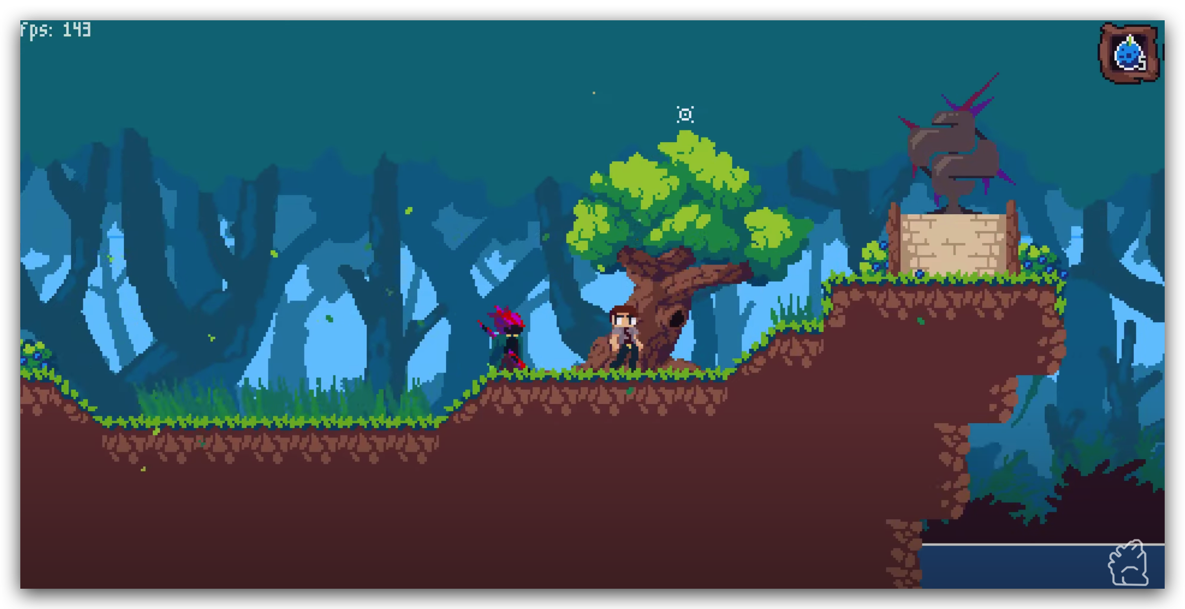

Description: Pixel, adventure-themed platformer game. The objective of the game is to avoid obstacles and collect objects and to get to the final destination (sort of like Mario).

1. Quest for the Forest Treasures: In this game, the player takes on the role of a forest explorer on a quest to find hidden treasures. The forest is full of obstacles and creatures that the player must overcome to reach their goal.

Must:

* The character shall be able to jump to avoid obstacles and reach higher platforms.
* a responsive and smooth control system to ensure the player has a seamless experience
* a pause and resume system so that the player can take a break （also a menu）
* responsive and intuitive UI that is easy to navigate
* sound effects and music that match the game's theme and enhance the gameplay experience
* have a help feature that provides instructions and hints for the player

Should:

* The difficulty of levels gradually gets harder as the player progresses (eg harder map/would require special skill to pass/traps)
* The player shall be able to collect power-ups that enhance their abilities, such as increased speed or invincibility.
* The Game should have a consistent art style/level design
* The game shall have a high score system that allows players to compete with each other.
* The player is given 3 lives at the beginning of the game, and the game ends when the player run out of lives
* The game shall have a variety of obstacles that the player must navigate, such as spikes, lava pits, and moving platforms

Maybe:

* controller support (Xbox/Dualshock controller)
* Story(?) where you explore different maps and meet different NPCs
* feature a boss fight at the end of each level
* The player shall be able to save their progress and continue from where they left off.

Others:

* be able to choose from different characters, each with their own unique abilities
* have a tutorial level to introduce the player to the game mechanics